Frogger
Part 1: Create the stage
1 | Create A Background  Click on the “Create a Background” button.  Call your new background  “frogger-background”. Click “Load Background” and find  /Backgrounds/background.gif  in the demo files.  Click OK. | 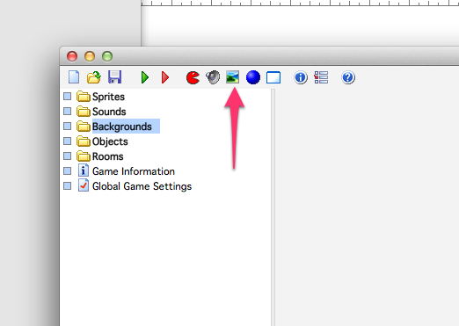  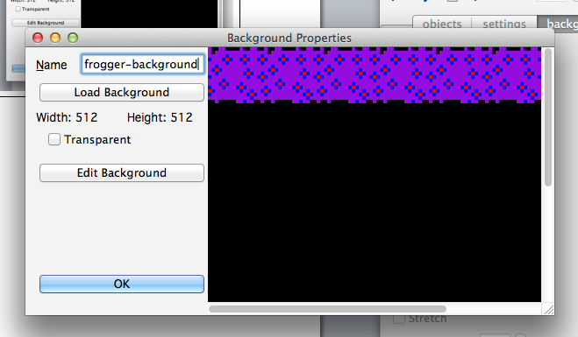
2 | Create A Room  Click on the “Create a Room” button.  Click “settings” and fill in:  Snap X: 64  Snap Y: 64  Name: road  Width: 512  Height: 512  Click “backgrounds” and pick “frogger-background” from the drop down list.  Click the check button. | 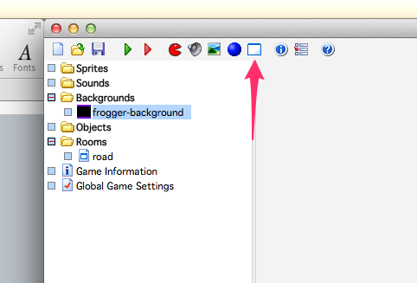  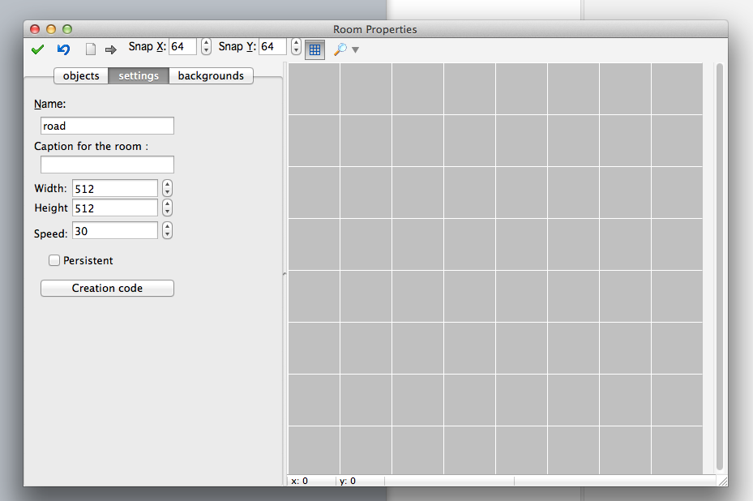  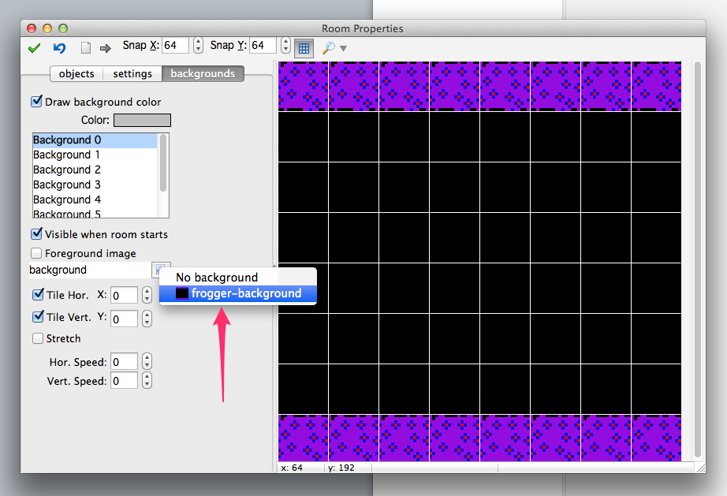
Part 2: Create Frogger
1 | Create A Sprite  Click on the “Create a Sprite” button.  Call your new sprite “frog-up”. Click “Load Sprite” and find /Sprites/Frog/frog-up.png  in the demo files. Make sure “Transparency” is checked.  Click OK. | 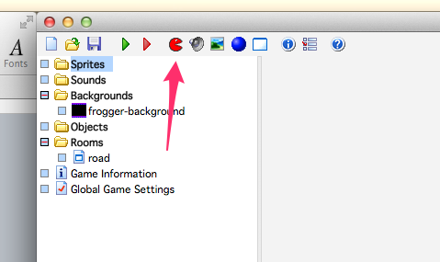  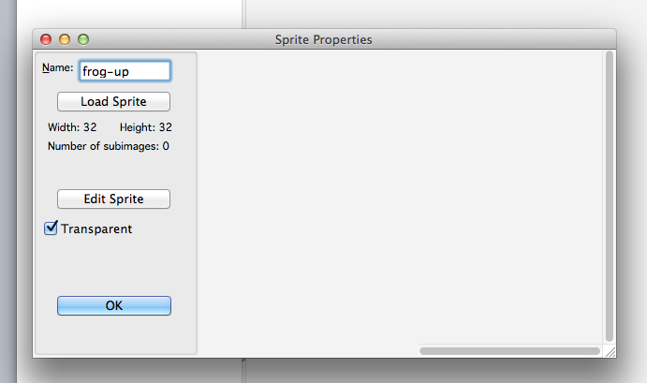
2 | Create An Object  Click on the “Create an Object” button.  Name object “frogger” and select the “frog-up” sprite from the drop down list. | 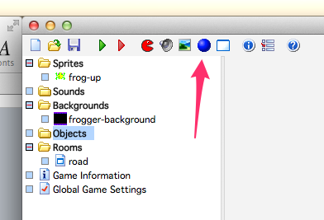  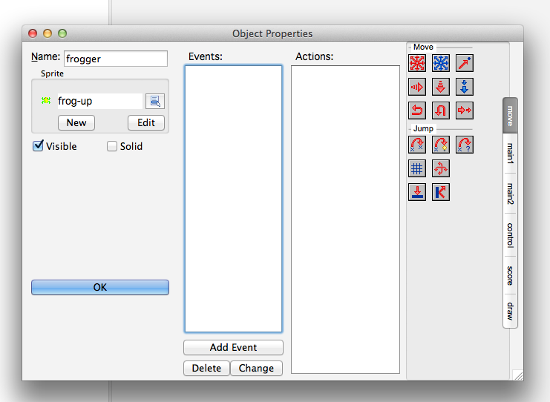
3 | Create An Event  Click “Add Event” and choose “Key Press”, then choose <up>.  With the “press <up>” event selected, drag the “Jump to Position”  In the window that pops up, make sure “Self” is checked in the Applies To box. Set Y to -64 and check the box next to “Relative” at the bottom”  Click OK | 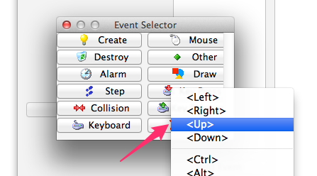  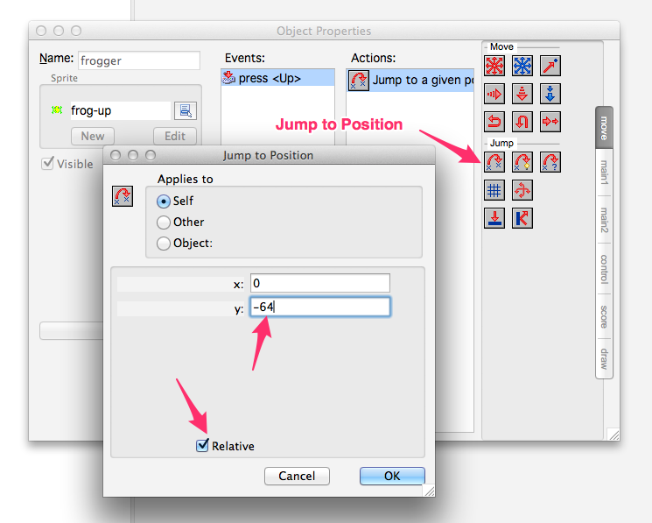
4 | Add Frogger to the Room  Double click on the “road” room. When the window opens, make sure you see frogger in the object list on the left and click in one of the grid squares on the bottom. Only click once.  Click the Check button when you are done. | 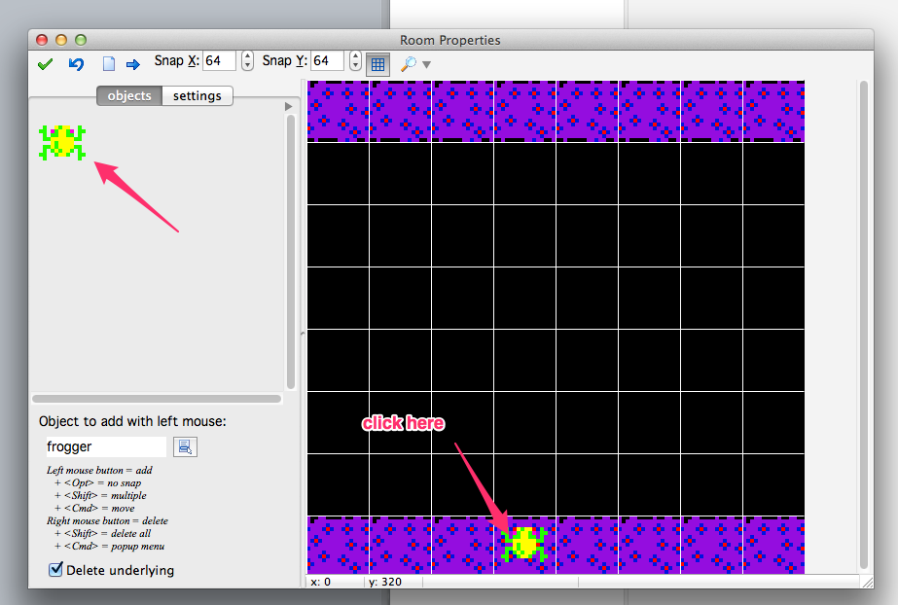
5 | Test  Click the “Run the Game” button. When the game appears, click on the window and press the Up key. Frogger jumps! Make him jump until he leaves the screen.  Close the window. | 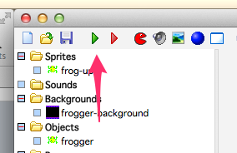
Part 3: Create An Enemy
1 | Create A Sprite  Create a sprite like you did before, but this time call it “car1” and load the /Sprites/Cars/car-1-right.png  Click OK. | 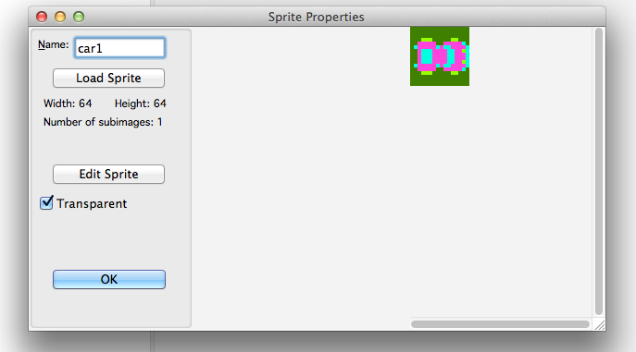
2 | Create An Object  Create an object like you did before, but this time, call it “car1” and set it’s sprite as “car1” that you just created.  Click “Add Event” and choose “Create”  Drag the “Start moving in a direction” action to the actions area. Click on the right arrow button and set the speed to 5. Click OK.  Click “Add Event” and choose Other > Outside Room.  Drag the “Wrap screen” action to the actions area. Leave the direction as “horizontal”.  Click OK  Click Ok to accept the changes. | 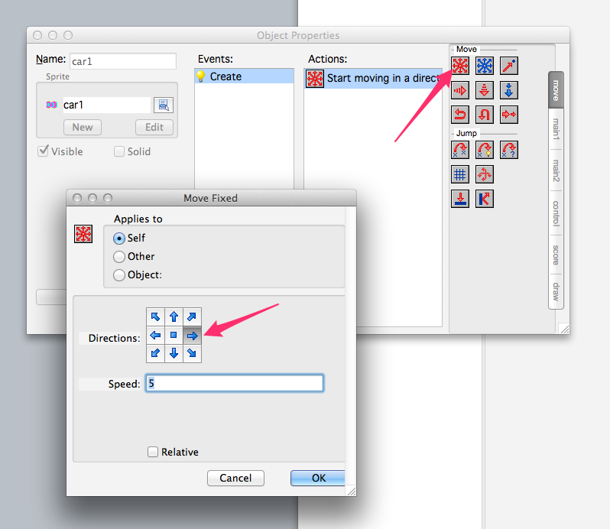
3 | Add the Car to the Room  Double click on the “Road” room. If the car1 object does not appear, select it from the drop down list. Click once on the road to add a car to the screen.  Click the check mark. | 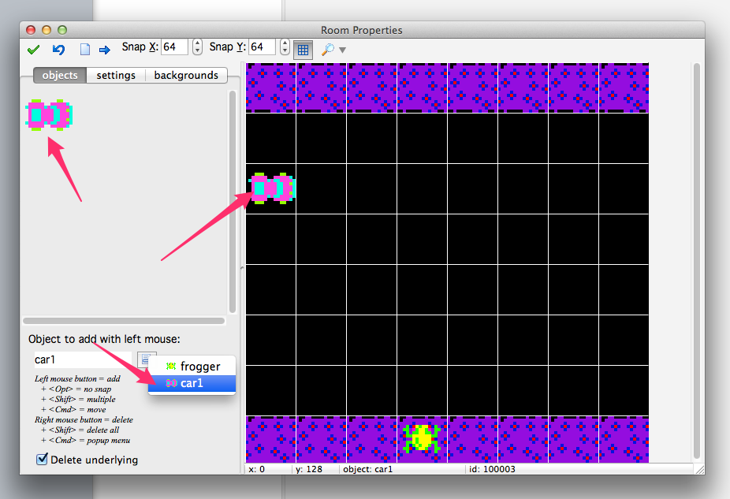
4 | Test  Click the “Run the Game” button. You’ll see the car loop across the screen. If you move frogger in it’s way, it will run past him and nothing will happen.  Close the window when you are done. | 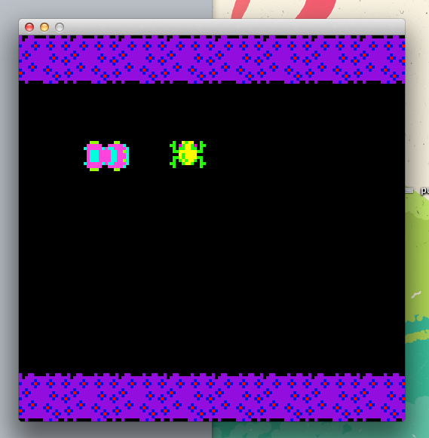
5 | Add A Lose Event  Double click on the car1 object. Add a “Collision” event, and choose frogger.  From the “main2” list of actions, add the “Display message” event and add the text “SPLAT” to it.  Add the “Restart Game” Event  Click OK | 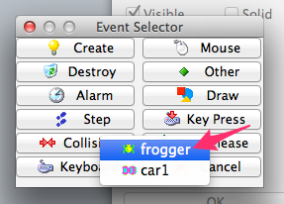  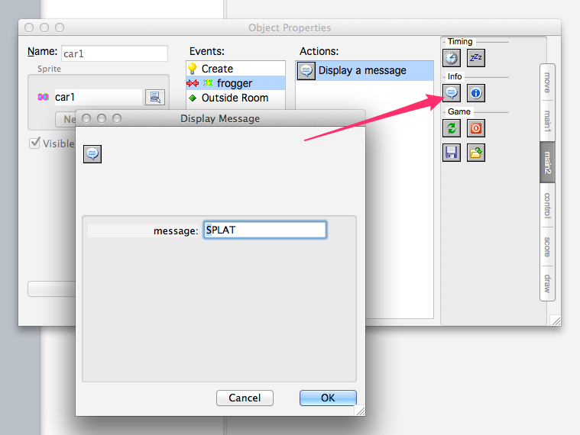  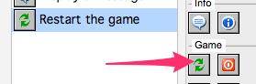
6 | Test  Click the “Run the Game” button. Move frogger in the way of the car. SPLAT!  Close the window when you are done | 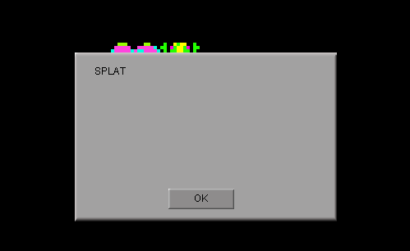
7 | Add A Win Event  Create a new sprite called “goal” and load the file /Sprites/Goal/goal.gif Uncheck “Transparent”  Create a new object called “goal” and assign it the “goal” sprite. Uncheck “Visible”.  Double click the “road” room. Add a line of goal objects at the top of the screen.  Double click on the “frogger” object. Add a Collision event. From the “main1” list, add a “Destroy the Instance” event. In the window, click “Object” and set it to “goal”  Add a 1000 milliseconds Sleep action.  Add a “Display Message” action that says “You Win!”  Add a “Restart the game” action. | 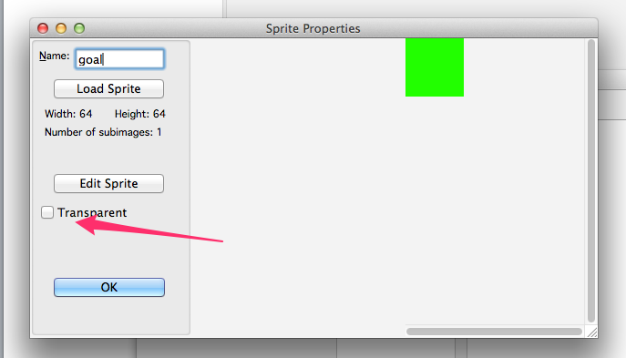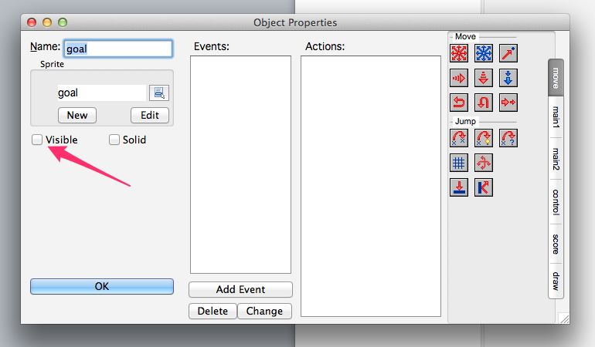  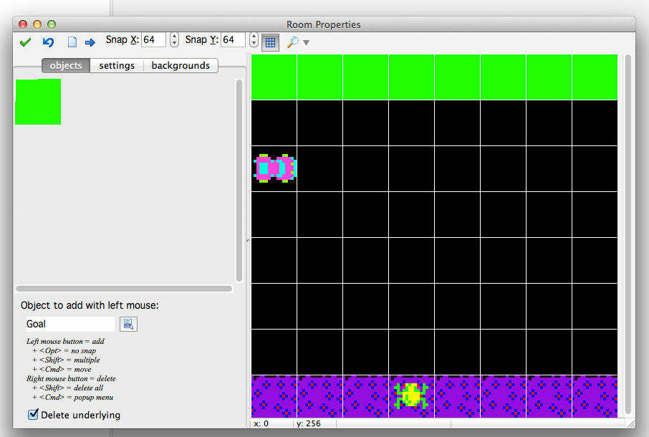  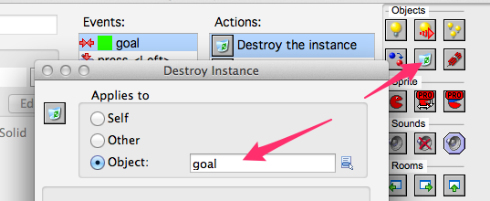  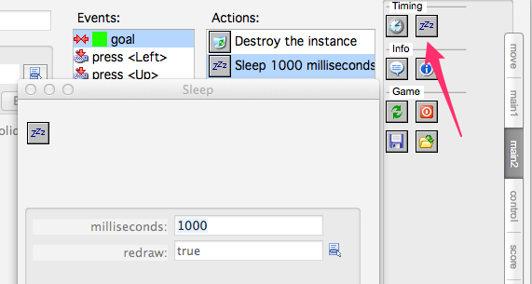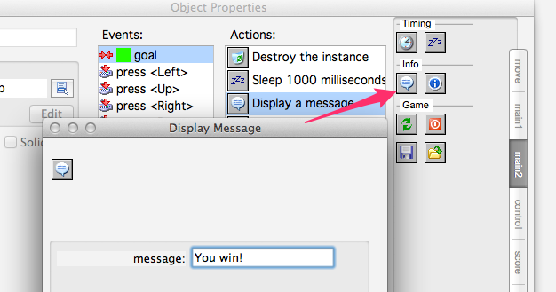  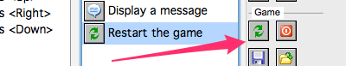
8 | Test  Make frogger jump to the opposite end. You Win! | 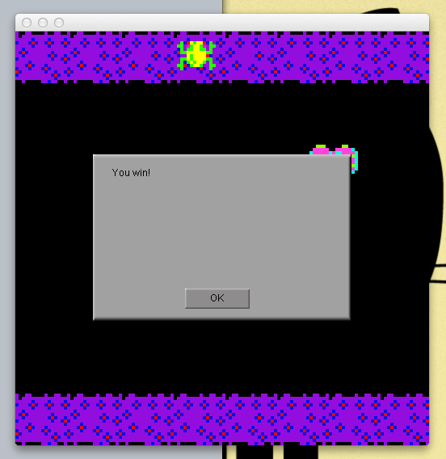
Next Steps
 | Make frogger move in other directions
 | Add more cars

